# Improving the medical care: A Data Analytic Approach

## Introduction

In medical centres, such a variety of patients come in search of a host of medical services. The purpose of these visits is either to administer routine check-ups or to provide the specific medical attention required by an individual in each case. This goal has been achieved by a systematic approach applied in the patient appointing stage when people are invited to answer the set of questions before their medical visits. These questions, ranging from a vast diversity that centers on age to specific health symptoms or concerns, will be an invaluable asset for measuring patient needs and preferences.

The key target of the project is early diagnosis and prevention of heart failure (Shah, D., Patel, S. and Bharti, S.K., 2020), among the most important health problems worldwide. Cardiovascular disorders could be prevented with early detection and pre-emptive management through regular screening, such as heart failure.

Data intelligence paired with machine learning identifies patterns of risks linked to heart disease (Aryal, S., 2021) based on questionnaire data, which are designed to help care improvement by means of targeted interventions and therapies. Such a shift to personalized healthcare, however, is a sign of a new era focusing on empowering patients and ensuring their overall welfare, aiming at reducing heart failure to a minimum in the future, as well as improving the energy of all patients (Awad, A., Trenfield, S.J., Pollard, T.D., Ong, J.J., Elbadawi, M., McCoubrey, L.E., Goyanes, A., Gaisford, S. and Basit, A.W., 2021).

# Chapter 1

## Data Collection and Preparation

The dataset used to predict heart failure was extracted from Kaggle, a platform that hosts datasets relevant to multidisciplinary fields. It has 918 observations, which are the merged set of five separate heart disease datasets. The features are 11 of the common ones that are applicable to predictive modeling.

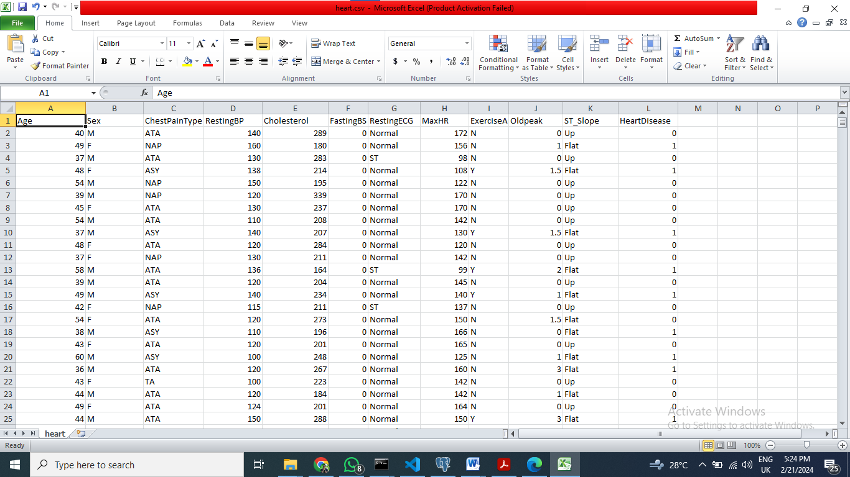

Title: Heart Failure Prediction Dataset: Exploratory Data Analysis

The dataset contains characteristics like age, gender, type of chest pain, cholesterol, blood sugar levels at fasting intervals, resting ECG readings, top heart rate, exercise-induced angina, old peak (given in depression), the slope of the peak exercise ST segment, and the output class, which indicates whether heart disease is present or absent.

Data cleaning procedures that include data imputation for missing entries and outlier handling were the first steps in data preprocessing (Borrohou, S., Fissoune, R. and Badir, H., 2023.). Techniques largely rely on imputation or deletion to address missing data issues, the latter yielding clean data. Outliers have been detected for exclusion and protection of analytical quality.

Categorical variables like the nature of chest pain (angina pectoris and exercise-induced angina) were transformed into numerical form so that they can be compatible with machine learning algorithms. Numerical features went through the normalization and standardization stage of processing to make sure the distribution and scale were consistent (Maharana, K., Mondal, S. and Nemade, B., 2022). In the end, the predictive algorithms could work better.

Stratified sampling is another method that was used to keep the balance between different classes of heart diseases and non-heart diseases, hence removing bias and robustly training the model.

The use of feature engineering techniques and the design of new variables and their combinations enable the encoding and, eventually, discovery of meaningful relationships in the data. For example, developing indices such as the ratio of cholesterol to blood pressure could be of added advantage for purposes of cardiovascular health.

The generated structured dataset with necessary attributes already present in it and carefully processed with the preprocessing techniques of data preparation builds the fundamental base for further analysis and model development to ultimately achieve dependable heart failure prediction. Incorporating machine learning algorithms, the dataset forms a robust and durable foundation for heart and cardiovascular failures prediction.

# Chapter 2

## Data cleaning

Data cleaning is a crucial step that facilitates the accuracy and consistency of the datasets used for analysis and modeling. The data cleaning of this project covers some crucial tasks such as standardizing the dataset for later analysis and prediction modeling that will help to manage more efficiently the delivery of patient care and deal with heart failure prediction and prevention.

Data cleaning starts with data processing paltry data in the data set. A lot of different circumstances, including data entry errors and partial responses, can lead to missing values. Strategies such as imputation or deletion are used to make up for the absence of data values while retaining the data identity.

Alongside other aspects of the process of data cleaning, detecting and removing outliers or inconsistencies within the dataset is another critical issue. Outliers may lead to bias in the generalization of the results, and consequently, it will reduce the accuracy of the predictive models. Such methods as statistical techniques and canon knowledge are exploited to be applied to outlier detection robustly.

Besides, data standardization refers to the uniform definition of data formats and representations across the database. In this process, numbers are normalized to make the same representation and also ensure that categorical variables are also standardized for analytics and model development.

During the cleaning phase, data integrity checking is also done to make sure the dataset complies with predefined integrity constraints. This refers to the confirmation of the connections between the multiple data items and data referential integrity to preserve the data quality and consistency.

In addition to approaching missing values and outliers, noise reduction techniques are used to avoid the effect of misleading or wrong data points on the dataset. This can comprise filtering the irrelevant data points or smoothing the signals to remove the noise in the dataset.

Through the regular completion of such data-cleaning tasks, the project intends to have a clean and credible dataset that forms the basis for valid data analysis and predictive modeling. Therefore, the cleaned data will become a source for reliable insight into patient care delivery and a foundation for predictive model creation on heart failure prediction and prevention.

# Chapter 3

## Scope of the problem

The cause of the problem is categorizing. More so, the objective is to calculate the chance of heart failure, enabling the different patient features and clinical markers. Classification divides examples into previously defined classes or labels using their features.

The dataset looks similar in such an environment, and the elements of the dataset are attributes like age, gender, physiological measurements and diagnostic test results. The task is to classify each observation into one of two categories: myocardial infarction or lack thereof, respectively.

The algorithm will be trained by the data to recognize the patterns and connections between the input features and the target variable (heart disease status). Following training, the algorithms will be able to come up with heart failure prediction chances for new unseen situations using the feature values only. The selection of the model, tuning of hyperparameters for optimization of model performance (Weerts, H.J., Mueller, A.C. and Vanschoren, J., 2020), model performance evaluation using metrics such as accuracy, precision, recall, and F1 score, and interpretation of the results of the model are some of the aspects of the problem scope.

In a nutshell, the problem scope includes a reliable classification model that can differentiate the presence or absence of heart disease, supplying healthcare professionals with early detection and proactive management of cardiovascular health (Gon, A., Hazra, S., Chatterjee, S. and Ghosh, A.K., 2023).

# Chapter 4

## Best Algorithm

In Chapter Four, there is an explanation of the choice of the best algorithm for predicting the occurrence of heart failure. The machine learning models and algorithms were evaluated to achieve quick patient classification that was based on the absence or presence of Heart Disease Severity levels (HDS) (Chang, V., Bhavani, V.R., Xu, A.Q. and Hossain, M.A., 2022).

The classification algorithms evaluated included:

1. Logistic Regression: Highly applicable for binary outcome prediction, logistic regression offers clear-cut, linear decision-making thresholds.

2. Random Forest Classifier: Random Forest utilizes decision trees, and it is resistant to overfitting and effective when using high-dimensional data.

3. Support Vector Machines (SVM): SVM ensures optimal class separation with suitable margins that are efficient in high-dimensional spaces purposed by different kernel functions.

Python was adopted for implementation, using libraries like scikit-learn and pandas for data manipulation. The preprocessing of data included

• Imputation or deletion of missing values,

• Conversion of categorical variables into one-hot encoding or label encoding, and

• Scaling of the numerical features using methods of Min-Max scaling or standardization.

Stratified sampling was utilized to guarantee equilibrium when training and testing the cases of heart disease and non-heart disease. In the model training process, I tested the methods of grid and random search to tune the hyperparameters with the cross-validation used for the evaluation of the model's performance.

# Chapter 5

## Model Evaluation

The innovative approaches in modern healthcare systems are fueled by data analytics and the adoption of artificial intelligence (Lee, D. and Yoon, S.N., 2021). In this case, the focus of the project is to make patient care more effective in medical centers by using data analytics methods. The target audience of the hospital being diverse and looking for different types of health services, the main goal is offering individualized and complex care that meets the needs of patients. By utilizing pre-consultation questionnaires and patient data, the mission is to determine the patterns which will provide evidence towards the risk of heart failure, thus improving early diagnosis and preventive measures. Through data intelligence and machine learning, the project aims to deliver quality healthcare by employing a strategy of active patient management and better clinical outcomes (Javaid, M., Haleem, A., Singh, R.P., Suman, R. and Rab, S., 2022).

The performance metrics used to evaluate the machine learning models were accuracy, precision, recall, and F1-score.Here are the results:

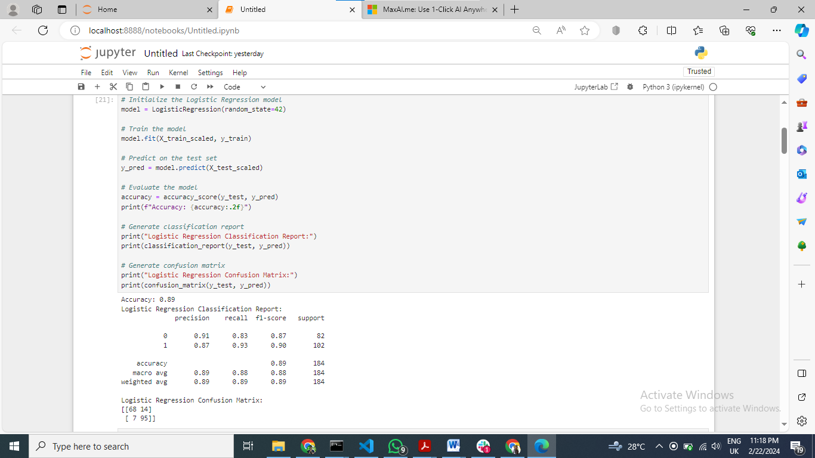

Title: Logistic Regression Model Training and Evaluation

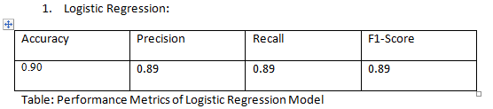

Confusion Matrix:

[[68 14]

[ 7 95]]

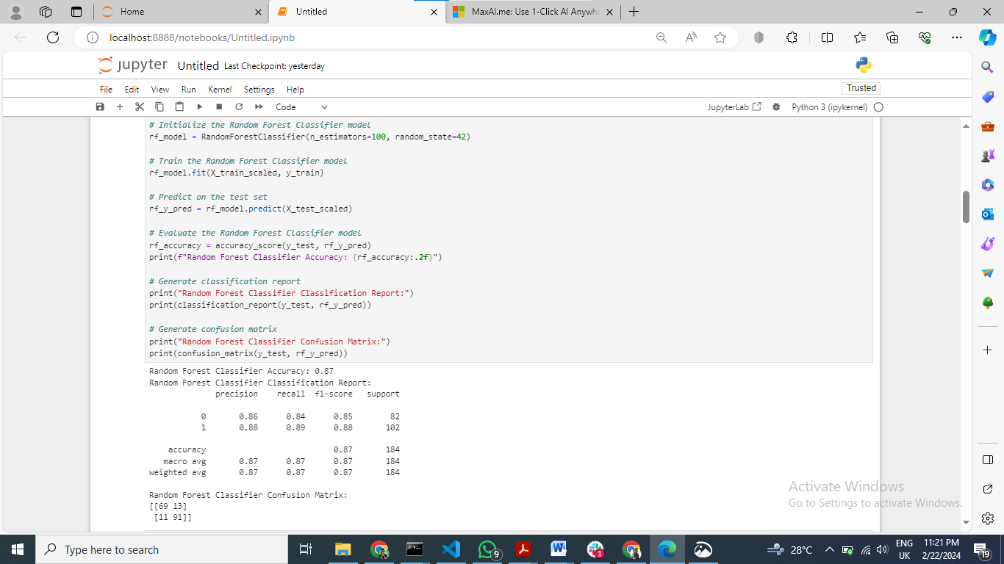

Title: Random Forest Classifier Model Training and Evaluation

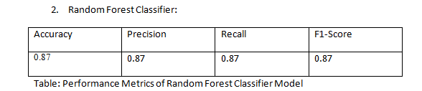

Confusion Matrix:

[[69 13]

[11 91]]

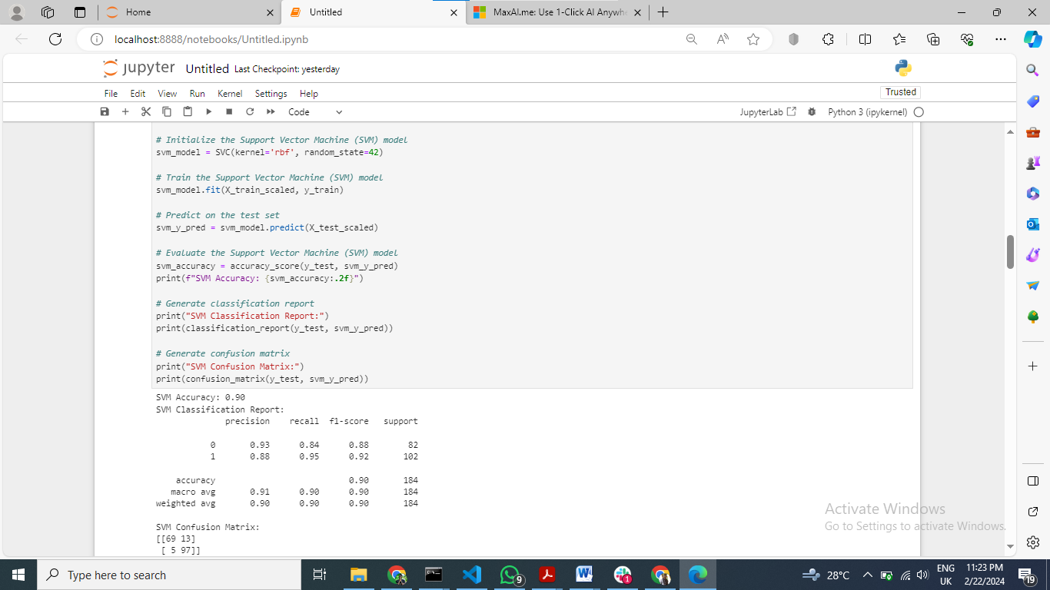

Title: Support vector Machine Model Training and Evaluation

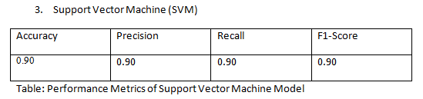

Confusion Matrix:

[[69 13]

[ 5 97]]

SVM turned out to be the most accurate model with the value of 0.90 then followed by the logistic regression model at 0.89 and random forest classifier at 0.87. However, though the above metric can be used, other measures like precision, recall, and F1-score can be used to fully determine the performance of a model (Orozco-Arias, S., Piña, J.S., Tabares-Soto, R., Castillo-Ossa, L.F., Guyot, R. and Isaza, G., 2020).

SVM has a precision, recall, and F1-score as the highest among the models, which means that it is most accurate in labeling the heart failure cases. Random forest and logistic regression classifier show slightly lower results but still good enough.

These results imply SVM to be the top model for heart failure with the highest performance in such a dataset in terms of evaluation metrics. Nevertheless the other aspects like the complexity of computation, interpretability, and the specifics of the healthcare setting should also be considered in the choice of the particular model.

As a whole the model evaluation provided valuable details regarding the efficacy of various machine learning algorithms in predicting heart failure thus aiming to improvise on patient care or outcomes in clinical practice (Olsen, C.R., Mentz, R.J., Anstrom, K.J., Page, D. and Patel, P.A., 2020).

# Chapter 6

## Recommendation to system improvement

Upon a comprehensive analysis of the model's performance and careful consideration of areas for enhancement, several strategic recommendations have emerged to fortify the system's capabilities

1. Enhanced Data Collection: Broaden the breadth of data collection to more encompassing patient attributes, medical indices and other parameters. Incorporation of supplementary variables such as genetic predispositions, lifestyle issues, and environmental influences will be helpful in capturing a more complete picture of the heart failure risk factors and thus, leading to a better prediction.

2. Advanced Algorithm Selection: Investigate advanced machine learning algorithms and ensemble approaches to be able to use a combination of forecasting models. Algorithms such as Gradient Boosting Machines (GBM), XGBoost and Neural Networks boast of high caliber modeling abilities and may perform better than the other algorithms in complex datasets.

3. Enriched Feature Set: Continue to chart the course by performing comprehensive feature selection and dimensionality reduction checks. Utilizing methods like Principal Component Analysis (PCA) or Recursive Feature Elimination (RFE) will help to determine the most significant components of the model, while minimizing computational overhead and model complexity.

4. Dynamic Model Updating: Enforce mechanisms for continuous model retraining to be in tune with the changes in demographics of the patient population and with any prevailing healthcare trends. Constantly adding new data and altering model parameters helps to keep the predictive model relevant and in accordance with clinical cases from real-world.

5. Interpretability and Clarity: Emphasize the orientation of machine learning models to being interpretable and explainable so that clinicians can use them easily in clinical settings. Tools like SHAP (Shapley Additive explanations) values and LIME (Local Interpretable Model-agnostic Explanations) enable medical professionals to know why particular predictions were made and to trust the process of the internal decision making of such tools.

Through this adoption, institutional culture of constant change and innovation will be created, which will give a new insight into precision medicine and individualized patient care (Subramanian, M., Wojtusciszyn, A., Favre, L., Boughorbel, S., Shan, J., Letaief, K.B., Pitteloud, N. and Chouchane, L., 2020). With through fast-paced measures and using data/information approaches the trip toward better health status and patients well-being can be accelerated, finally transforming the modern healthcare system in a totally innovative way.

# References

1. Shah, D., Patel, S. and Bharti, S.K., 2020. Heart disease prediction using machine learning techniques. *SN Computer Science*, *1*, pp.1-6.
2. Aryal, S., 2021. Application of Artificial Intelligence/Machine Learning for Cardiovascular Diseases (Doctoral dissertation, University of Toledo).
3. Awad, A., Trenfield, S.J., Pollard, T.D., Ong, J.J., Elbadawi, M., McCoubrey, L.E., Goyanes, A., Gaisford, S. and Basit, A.W., 2021. Connected healthcare: Improving patient care using digital health technologies. *Advanced Drug Delivery Reviews*, *178*, p.113958.
4. Borrohou, S., Fissoune, R. and Badir, H., 2023. Data cleaning survey and challenges–improving outlier detection algorithm in machine learning. *Journal of Smart Cities and Society*, *2*(3), pp.125-140.
5. Maharana, K., Mondal, S. and Nemade, B., 2022. A review: Data pre-processing and data augmentation techniques. *Global Transitions Proceedings*, *3*(1), pp.91-99.
6. Gon, A., Hazra, S., Chatterjee, S. and Ghosh, A.K., 2023. Application of Machine Learning Algorithms for Automatic Detection of Risk in Heart Disease. In *Cognitive Cardiac Rehabilitation Using IoT and AI Tools* (pp. 166-188). IGI Global.
7. Lee, D. and Yoon, S.N., 2021. Application of artificial intelligence-based technologies in the healthcare industry: Opportunities and challenges. *International Journal of Environmental Research and Public Health*, *18*(1), p.271.
8. Javaid, M., Haleem, A., Singh, R.P., Suman, R. and Rab, S., 2022. Significance of machine learning in healthcare: Features, pillars and applications. *International Journal of Intelligent Networks*, *3*, pp.58-73.
9. Orozco-Arias, S., Piña, J.S., Tabares-Soto, R., Castillo-Ossa, L.F., Guyot, R. and Isaza, G., 2020. Measuring performance metrics of machine learning algorithms for detecting and classifying transposable elements. *Processes*, *8*(6), p.638.
10. Olsen, C.R., Mentz, R.J., Anstrom, K.J., Page, D. and Patel, P.A., 2020. Clinical applications of machine learning in the diagnosis, classification, and prediction of heart failure. American Heart Journal, 229, pp.1-17.
11. Subramanian, M., Wojtusciszyn, A., Favre, L., Boughorbel, S., Shan, J., Letaief, K.B., Pitteloud, N. and Chouchane, L., 2020. Precision medicine in the era of artificial intelligence: implications in chronic disease management. *Journal of translational medicine*, *18*(1), pp.1-12.
12. Chang, V., Bhavani, V.R., Xu, A.Q. and Hossain, M.A., 2022. An artificial intelligence model for heart disease detection using machine learning algorithms. *Healthcare Analytics*, *2*, p.100016.